**CSCI 5622 – Machine Learning**

Nick Ketz

Assignment 1 Analysis

**What is the role of the number of training points to accuracy?**

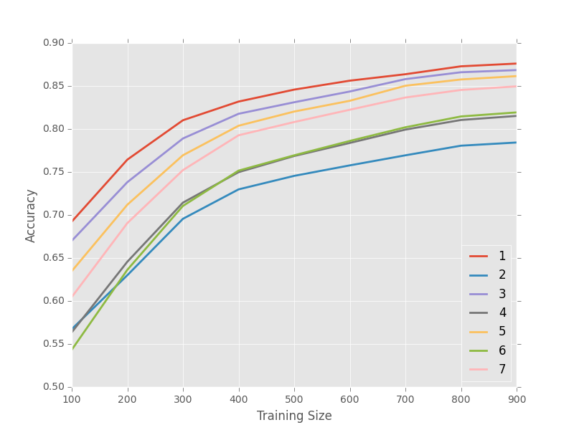As shown in Figure 1, the more training examples, the better the accuracy. Also, the more training examples, the less detriment larger K values have on accuracy .

**What is the role of ~k~ to accuracy?**

As shown in Figure 1, even numbered K values perform worse than odd numbered K’s. Also, for small training sets, low K values perform better than large, however this advantage goes away with larger training sets.

Figure 1: Accuracy as a function of Training Size. Each line is a different K value, with even values performing worse than odd.

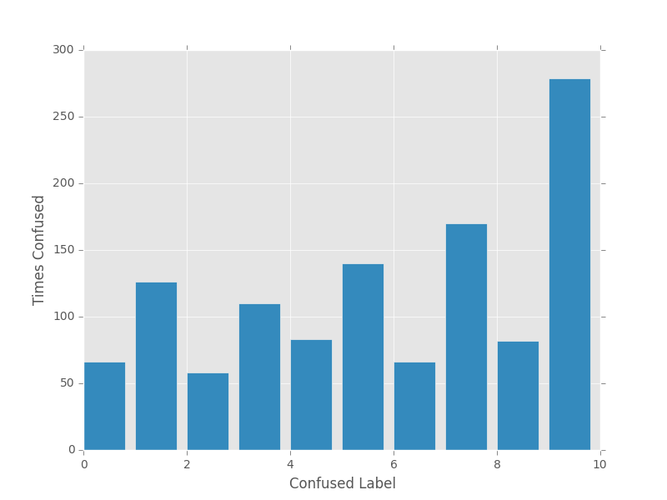

**What numbers get confused with each other most easily?**

As seen in Figure 2, In general label 9 is most often confused with other labels. ­

Figure : Count of times a given label was confused with the correct label. Confused label is shown on the x axis